The closed vessels through which blood circulates within the body known as
A. Blood Vessels
B. A-V Node
C. S-A Node
D. Pace maker
ANSWER: A

This one is the function of the artery:
A. Carrying the blood away from the heart
B. Carrying deoxygenated blood
C. Carrying pure blood
D. None of these
ANSWER: A

____________carry blood towards the heart
A. Arteries
B. Veins
C. Capillaries
D. None of these
ANSWER: B

_____________are thick walled vessels
A. Arteries
B. Veins
C. Capillaries
D. None of these
ANSWER: A

____________are thin walled blood vessels

A. Arteries
B. Veins
C. Capillaries
D. Both B and C
ANSWER: D

The ______________carry oxygenated blood except pulmonary artery
A. Arteries
B. Veins
C. Capillaries
D. None of these
ANSWER: A

The ___________ carry deoxygenated blood except pulmonary vein
A. Arteries
B. Veins
C. Capillaries
D. None of these
ANSWER: B
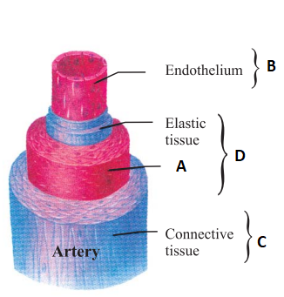
What does A represent in the given diagram?
A. Cardia muscle
B. Smooth muscle
C. skeletal muscle
D. Tunica intima
ANSWER: B

What does B represent in the given diagram?
A. Tunica intima
B. Tunica media
C. Tunica adventitia
D. skeletal muscle
ANSWER: A

What does C represent in the given diagram?
A. Tunica intima
B. Tunica media
C. Tunica adventitia
D. skeletal muscle
ANSWER: C

What does D represent in the given diagram?
A. Tunica intima
B. Tunica media
C. Tunica adventitia
D. skeletal muscle
ANSWER: B
The wall of an artery consists of _______tunics
A. 2
B. 3
C. 5
D. 6
ANSWER: B
_______ can be seen as blue vessels under the skin
A. arteries
B. veins
C. capillaries
D. none
ANSWER: B
_______ are pink in color and are situated within the muscles
A. arteries
B. veins
C. capillaries
D. none
ANSWER: A
Aorta have:
A. Thick muscular walls
B. No walls
C. thin muscular walls
D. none
ANSWER: A

